Given a string s and an integer array indices of the **same length**.

The string s will be shuffled such that the character at the ith position moves to indices[i] in the shuffled string.

Return *the shuffled string*.

**Example 1:**

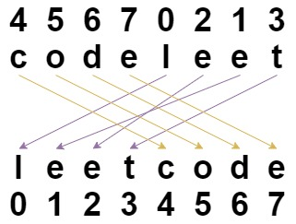

**Input:** s = "codeleet", indices = [4,5,6,7,0,2,1,3]

**Output:** "leetcode"

**Explanation:** As shown, "codeleet" becomes "leetcode" after shuffling.

**Example 2:**

**Input:** s = "abc", indices = [0,1,2]

**Output:** "abc"

**Explanation:** After shuffling, each character remains in its position.

**Example 3:**

**Input:** s = "aiohn", indices = [3,1,4,2,0]

**Output:** "nihao"

**Example 4:**

**Input:** s = "aaiougrt", indices = [4,0,2,6,7,3,1,5]

**Output:** "arigatou"

**Example 5:**

**Input:** s = "art", indices = [1,0,2]

**Output:** "rat"

**Constraints:**

* s.length == indices.length == n
* 1 <= n <= 100
* s contains only lower-case English letters.
* 0 <= indices[i] < n
* All values of indices are unique (i.e. indices is a permutation of the integers from 0 to n - 1).